13th September 2019

Dear

Leaholme Court Regeneration
We just wanted to give you an update on the progress made on the Leaholme Court regeneration scheme. Our team has been continuing pre-application discussions with Cotswold District Council’s planning department - as the development is in a conservation area these discussions are quite protracted.

We have had to complete extra archaeological surveys due to the proximity of Leaholme Court to the Roman Forum remains on Tower Street and we will have to design the foundations before we can submit an application for planning permission.

We will hold a Planning Engagement Event, where we will invite neighbours and former customers to comment on the planning drawings prior to submission. As soon as we have a date, time and location in mind we will write to you again and I do hope you will be able to join us. Even if you can’t attend the open event, there will still be an opportunity to give us your feedback and thoughts.

Various colleagues will continue to visit the area regularly, but if you notice anything suspicious or unsafe regarding an empty property at Leaholme Court we would very much appreciate if you could contact Alex Suter (Commercial Property Surveyor) on 07970 650438 or Bromford on 0330 1234 034.
Thank you for your cooperation and we look forward to seeing you soon.
Yours sincerely,
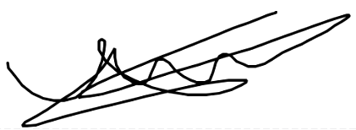
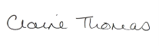
Claire Thomas James Trotter
Regeneration Manager Regeneration Coordinator

T: 01989 730493 M: 07976086134
M: 07979 707156
Email: claire.thomas@bromford.co.uk Email: james.trotter@bromford.co.uk

