16th September 2019

Dear

Cross Tree Crescent & Oakley Flats Regeneration
We wanted to give you an update on the progress made on the Cross Tree Crescent and Oakley Flats regeneration scheme.

We submitted the planning application to Cotswold District Council in May, there have been no objections received by the planning authority however we are now trying to agree the materials that will be used on the new homes. We are looking to appoint a building contractor within the next couple of weeks. We will then update you on the programme.

Various colleagues will continue to visit the area regularly, but if you notice anything suspicious or unsafe regarding an empty property at Cross Tree Crescent and Oakley Flats we would very much appreciate if you could please contact Alex Suter (Commercial Property Surveyor) on 07970 650438 or Bromford on 0330 1234 034.
Thank you for your cooperation and we look forward to seeing you soon.
Yours sincerely,
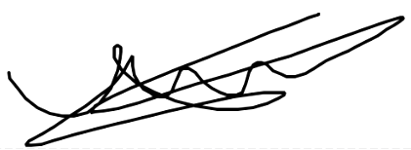
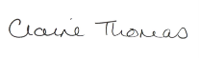
Claire Thomas James Trotter
Regeneration Manager Regeneration Coordinator

T: 01989 730493 M: 07976086134
M: 07979 707156
Email: claire.thomas@bromford.co.uk Email: james.trotter@bromford.co.uk

