12th September 2019

Dear

Main Street and Lullington Road Regeneration

With autumn fast approaching we just wanted to update you on our regeneration scheme at Clifton Campville.

The hoarding fence on Main Street will be taken down at the end of October and landscaping will then commence fronting Main Street. The works on site are progressing well, with the first shared ownership properties due to be completed in November. We expect the first of the rented new homes to be ready for occupation by mid December 2019 / early January 2020, with completion of the whole site anticipated around February/March 2020.

The name of new road accessed from Main Street will be called Manor Rise, the new homes on Lullington Road will have the same address as previously.

If you know anyone who would be interested in one of the new rented properties, please ask them to register on the Homes Direct website, www.homesdirect.org.uk. This is where the new properties will be advertised once they are ready and, as they will be advertised 12 weeks before they have been completed, it is probably wise to do this as soon as possible.

Details on the shared ownership homes for sale at Manor Rise, can be found on our website at www.bromford.co.uk/poultneyrise (Poultney Rise will be the name used for marketing purposes). If you do know anyone interested in shared ownership please ask them to ring 0800 0852 499.

If you have any queries about the construction please contact Tim Hotchkiss the Site Manager on 07894 598343, who is responsible for the development. Our Neighbourhood Coach working in this area is Vikki Monteith and she can be contacted on 07718 966228. Alternatively, we will still be involved so please feel free to telephone or email us about any unresolved issues you have.

Yours sincerely,

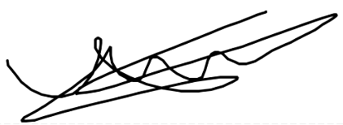
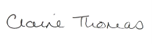
Claire Thomas James Trotter
Regeneration Manager Regeneration Co coordinator

T: 01989 730493 M: 07976086134
M: 07979 707156
Email: claire.thomas@bromford.co.uk Email: james.trotter@bromford.co.uk

